Objective: To capture/document current workflows to have baseline for tracking changes overtime by staff as KEIMS does not retain edit history for the modification to the workflow – but only timestamps the Created and Last Updated user information.
- Access Admin:
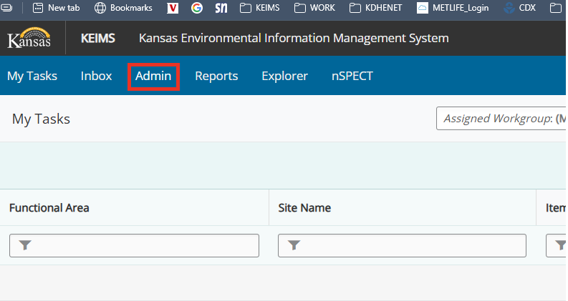
- Scroll down and click on Workflow Templates on left menu options:
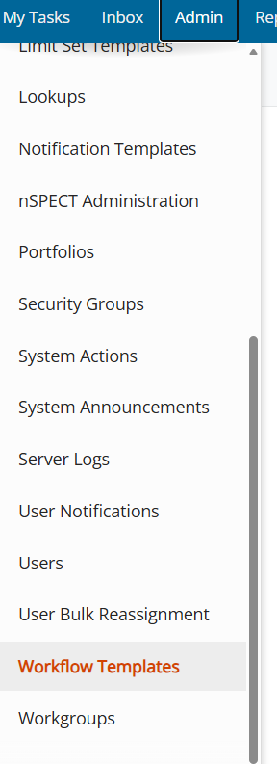
- Sort on AIR:
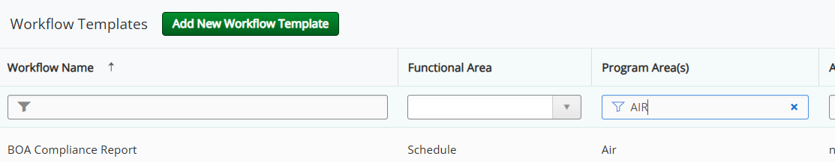
- For each AIR workflow – take screen shots to document the current workflow in word document and save as workflow title – eg. BOA Compliance Report:
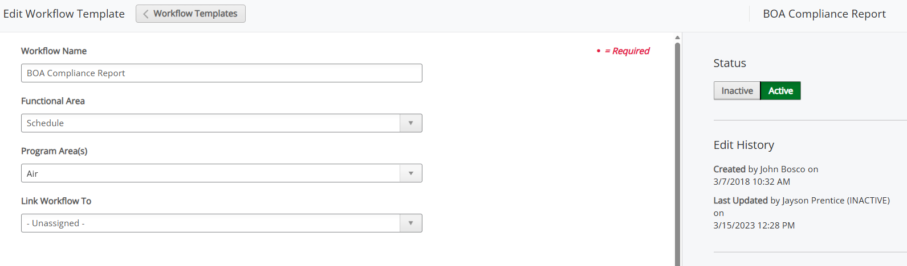
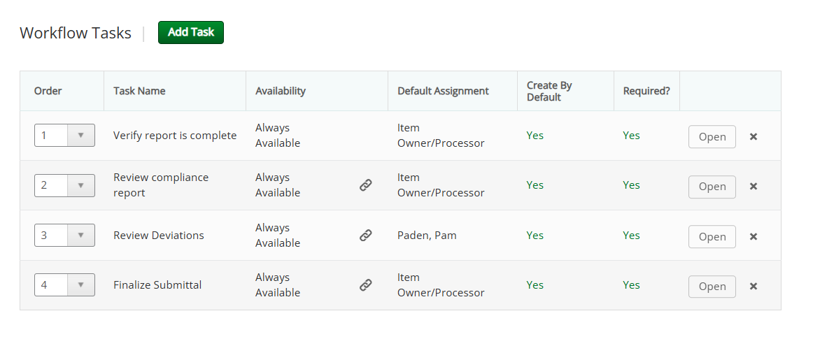

- There are 32 AIR workflows as of 7/1/2026:
